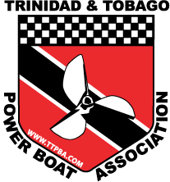
Trinidad & Tobago Powerboat Association
2019 Boat Registration Form

Name of boat
Where kept
Owner of Boat/Captain
Mailing Address (1st line)
Mailing Address (2nd line)
Mailing Address (city)
Phone (h)
Phone (w)
Phone (cell)
Fax
e-mail
Racing Class
Racing Number
Colour of hull
Colour of deck
Length
Make/Model (mono/cat)
Designer
Year of Manufacture
Material
Inboard/Outboard
Number of Engines
Make/Model of engine/s
Total Cubic Capacity
Total Rated Horsepower
Fuel Capacity
Number of Crew
Canopy (Yes or No)
Sponsors

I certify that the above information is Correct: | Owner/Captain: Date:

***** For Official Use Only ******
Based on the information contained herein, this boat is certified to race in: | Class:
For and on Behalf of the TTPBA:
Registration Fee Paid: | ___ ___ ___  (Yes) (No) (N/A)
Registration Fee Amount: | $
Date | _____ / ______ / _____  (DD) (MM) (YY)

